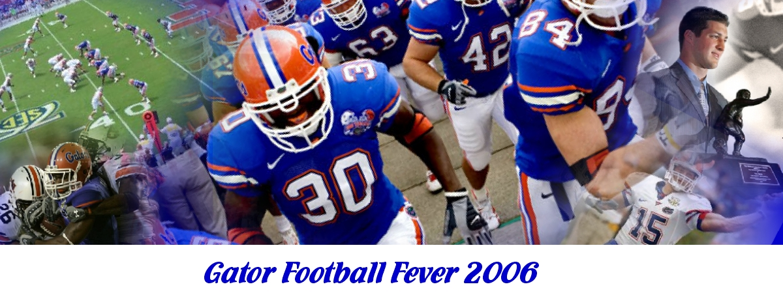
Friends, now for the first time you can own your very own copy of the exciting new video,
Gator Football Fever 2006.
- Relive the excitement as the UF Gators chomped and swamped the humbled Ohio State Buckeyes in the 2006 BCS Championship Game!
- Remember and enjoy the game by game accomplishments of the 2006 season!
- Enjoy reviewing both the Best Offensive Plays and also the Best Defensive Plays.
- Watch the spotlight on Chris Leak, the exciting UF quarterback who was voted the Most Valuable Player of the BCS Championship game.
- Equally as exciting, enjoy the running commentary and personal stories from Tim Tebow, the video’s celebrity host. Playing as a freshman, Tim Tebow was an outstanding “utility man” in the BCS Championship game, running for 39 tough yards including a touchdown, and also throwing a touchdown on his only pass attempt. Even more impressive however, in the following 2007 season, Tim became the first college sophomore ever to win the coveted Heisman Trophy.
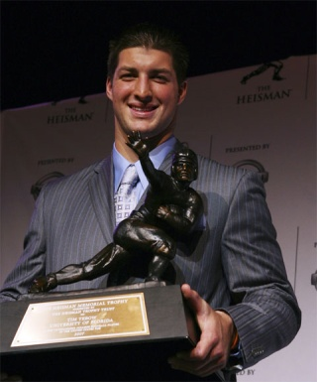
Gator Football Fever 2006 video contains the following:
PRE-ORDER YOUR COPY TODAY!
$24.95 + 4.95 shipping and handling.
Release Date April 1st
First 2006 copies sold are autographed by our host Tim Tebow.

Order today!
www.GatorVideo.com
***Also Available in HD format***
1-352-GO-GATOR
Or mail this form with check or money order to: Gator Video PO BOX 2006 Gainesville, FL 32601
HD Blu-ray_____ DVD ______ VHS____
Name_________________________________
Address ______________________________
City State & Zip ________________________

Hosted By
Tim Tebow

- Leads the SEC in total offense and pass efficiency.
- Three-time SEC Offensive Player of the Week.
- Single-season SEC rushing touchdown record holder of any player in league history.
- UF record-holder in rushing attempts (27) and yards (166) in a single game by a quarterback with his effort against Ole Miss.
- Set the UF single-game rushing record with five touchdowns against South Carolina.
- Heisman Trophy winner 2007 Season

Gators relive the excitement

Best Offensive Plays 2006
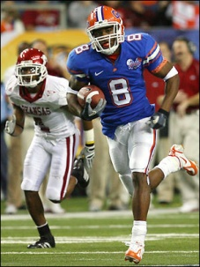
Percy Harvin rushes for 105 yards against Arkansas keeping them on their heels.
Gator Football Fever 2006 is action packed with footage from the entire championship year of 2006. The footage is spotlighted and narrated by our host Tim Tebow. The insight that Tim provides will raise your temperature as you relive all of the best footage from the 2006 season. Tim’s charisma as well as his spirit of a Gator shines and will allow you to relive the outstanding championship year of 2006 for years to come. Available on DVD, Blu-ray and VHS.
ALL THIS FOR ONLY $24.95
Order your copy today for our release date of April 1st. The first 2006 orders will be autographed by Tim Tebow. Priority shipping available at www.GatorVideo.com.

Best Defensive Plays
2006
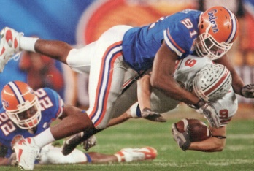
Derrick Harvey had 3 sacks and a fumble recovery as Florida held the high-powered Buckeyes to 82 total yards in the BCS Championship game.

Spotlight on
Chris Leak
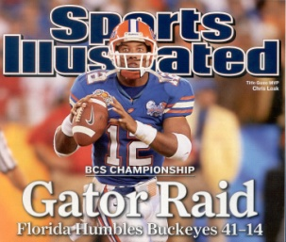
Chris earned a spot on the cover of Sports Illustrated after being voted MVP of the BCS Championship game.

